PARA U12 State Championships
Roundtop Mountain Resort
February 20-22, 2025


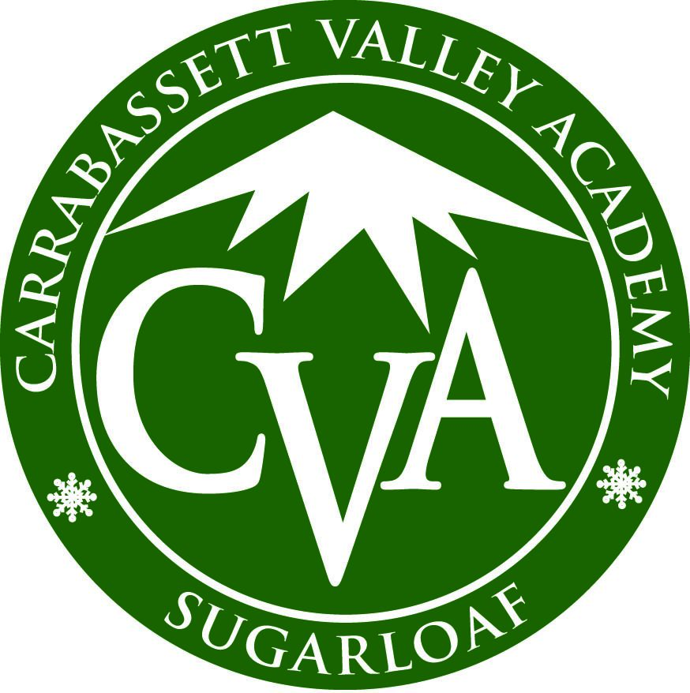

Dear U12 PARA Racer,

Congratulations! Your racing results have qualified you for an invitation to the 2026 PARA U12 State Championship Derby February 20-22, 2026 at Roundtop Mountain Resort.

If you cannot participate in the U12 Derby, please notify your PARA Regional Chair and coach immediately.

Event Format
Friday, February 20- Registration and Bib Pick-Up Upper Level Tubing Lodge. On-site registration also available Saturday morning at Event Tent.
Saturday - 3 runs Slalom, Exhibition Run
Sunday - 3 runs Giant Slalom, Exhibition Run

Registration
Both online and on-site registration required for all racers. Online registration must be completed at AdminSkiRacing.com. Online registration for racers and coaches closes at noon on Wednesday, February 18, 2026.
Required on-site registration and bib pick-up Friday, February 20 or Saturday, February 21 for bib pick-up, goodie bags for each racer and pre-purchased lift tickets and pizza party tickets.
*Coaches are also required to register by Wednesday, February 18 to receive lift tickets.

Registration fee of $150.00 for each racer will cover the following:
-Two days of races, registration fees and PARA head tax
-Continental breakfast for racers Saturday and Sunday in the Event Tent sponsored by Dunkin’
-Saturday afternoon S’mores Party
-Sunday afternoon Pizza Party and Awards Ceremony at Event Tent for each racer (additional tickets for family members are available for purchase at AdminSkiRacing.com and on-site registration)
-State championship sweatshirt and goodie bag

Championships Hoodie Size Availability
Please email u12derbychair@gmail.com to specify hoodie size preference. Only Youth XL or Adult Medium are available. Quantities are limited and will be allotted based on when emails are received.

Post Season
Results from the U12 State Championship Derby will be used to select the Pennsylvania State Team for the following post-season event:
Francis Piche Invitational
Gunstock Ski Club
Gunstock, New Hampshire, March 13-15. Additional training days March 11-12
Quotas: Top 11 Women, Top 11 Men
Qualifications for post-season events will be determined by World Cup Points based on the conditions (weather, snow, etc.). See Rules for U12 State Championships in PARA Rules and Procedures 2025-2026 Guide .

Location
Roundtop Mountain Resort Tubing Lodge
925 Roundtop Road
Lewisberry, PA 17339
Event Tent is located directly behind the tubing lodge. Parking is available at the Tubing Lodge. Please follow PARA Event parking signs. Cars not parked in designated PARA event area will be asked to move.

Lift Tickets
Lift tickets are not covered by registration fee. Racers and family members without an Epic Pass may purchase lift tickets for Saturday and Sunday at a discounted rate of $65 a day by sending an email to RoundtopGuestServices@vailresorts.com. Please mention you are purchasing race tickets and include your name, address and phone number. Roundtop employees will then contact you for payment. Purchased tickets will be available for pick-up at on-site event registration. The deadline to contact Roundtop for discounted tickets is noon on Thursday, February 19, 2026. Only tickets purchased by that time will be available for pick-up at event registration.

Volunteers
Each racer is strongly encouraged to bring one race worker (adult) who can assist with one of the two race days. Sign-ups can be found at
SignUpGenuis. Volunteer course workers and gate judges will receive one complimentary lift ticket as needed for their volunteer day. Tickets can be obtained at on-site registration

Rules and Regulations
Race Bibs will be provided at on-site registration. Bibs must be worn and visible to access early lift loading, course, race start, food and events. Helmets are required per USSS Rules.
All Racers must stage their equipment in the designated staging area at the top of the race hill. No equipment is permitted in the race arena. Please do not block skier traffic.

Food Allergies
Please send any food allergy concerns to u12derbychair@gmail.com

2026 PARA U12 Derby
EVENT SCHEDULE
all events and times are estimated and dependent on weather and conditions
Friday, February 20, 2026 | Evening Registration
5:00 - 8:00 pm | Tubing Lodge - Roundtop Mountain Resort  925 Roundtop Road  Lewisberry PA 17339
Saturday, February 21, 2026 | Slalom Race Day
7:00 - 8:00 am | Morning Registration and Arrival -Event Tent behind tubing lodge  Complimentary continental breakfast available in Event Tent for racers sponsored by Dunkin’
7:30 am | Coaches Meeting-SRRC Comp Center bottom of Exhibition Slope  **Coaches must register before noon on Wednesday, February 18 to obtain tickets
8:00 am | Lift Access for Coaches and Athletes ONLY  Officials and Course Workers Meeting at SRRC Comp Center bottom of Exhibition Slope
8:15 am - 9:00 am | 1st Run Inspection-Exhibition Slope  Inspection entry closed at 8:45 am
9:00 am | Lift Open to All  Officials and Course Workers move into position
9:15 | Forerunners
9:30 | First Run, Slalom, Exhibition Slope
TBA | Second Run, Slalom, Exhibition Slope
11:00 am estimated | Break for re-set of third course
TBA | Third Run Course Inspection Exhibition Slope
TBA | Officials and Course Workers move into position
TBA | Third Run, Slalom, Exhibition Slope
2:30 pm estimated | S’mores Party- Fire Pit at Event Tent
Sunday, February 22, 2026 | Giant Slalom Race Day
7:00 am - 8:00 am | Arrival-Event Tent. Complimentary Continental Breakfast for racers sponsored by Dunkin’
7:45 am | Coaches Meeting- SRRC Comp Center bottom of Exhibition Slope
8:15 am - 9:00 am | 1st Run Course Inspection-Exhibition Slope  Inspection entry Closed at 8:45 am
9:00 am | Officials and Course Workers move into position
9:30 am | Forerunners
9:30 am | First Run, Giant Slalom, Exhibition Slope
TBA | Second Run, Giant Slalom, Exhibition Slope
11:00 am estimated | Break for re-set of third course
TBA | 3rd Run Course inspection, Exhibition Slope
TBA | 3rd Run, Giant Slalom, Exhibition Slope
2:30 pm estimated | Pizza Party-Event Tent  Racers’ bibs and purchased tickets required for entry
3:30 pm estimated | Awards Ceremony-Event Tent  Slalom- 1st-3rd trophies  4th-10th medals, male and female  Giant Slalom- 1st-3rd trophies  4th-10th medals, male and female  Overall Plaques top male and top female  PARA State Team Announcement  Francis Piche Invitational Team Designation

Other Information
Live Timing results will be posted for each run after every racer has completed that run. Live Timing results are unofficial.
Questions or protests must be directed to your coaches who will then approach the appropriate Race Officials.
Non-skiing parents and guests are asked to follow the walking path signs which will direct you from the Tubing Lodge to the Event Tent and the bottom of the Exhibition race course.
Restrooms are available in the Tubing Lodge.

Good Luck Ski Fast Have Fun

Any questions, please contact

U12 Derby Chair
Alice Anderson
717-756-4615
u12derbychair@gmail.com

U12 PARA Age Chair
Tim Brown
610-391-0257
u12racingchair@para.org

